1.

**Code:**

package com.yajith.matrix;

import java.util.Scanner;

public class Main {

static int N=3;

static int inverse(int a,int n)

{

a=a%n;

for(int b=1;b<n;b++)

{

if((a*b)%n==1)

{

return b;

}

}

return 1;

}

static int det(int m[][],int num)

{

int e=0;

if(num==1){return m[0][0];}

int temp[][]=new int[N][N];

int s=1;

for(int f=0;f<num;f++)

{

cofactor(m,temp,0,f,num);

e+=s*m[0][f]*det(temp,num-1);

s=-s;

}

return e;

}

static void cofactor(int mat[][],int temp[][],int p,int q,int n)

{

int i=0,j=0;

for(int r=0;r<n;r++)

{

for(int c=0;c<n;c++)

{

if(r!=p&&c!=q)

{

temp[i][j++]=mat[r][c];

if(j==n-1)

{

j=0;

i++;

}

}

}

}

}

public static void main(String[] args) {

Scanner s=new Scanner(System.in);

int[][] mat=new int[N][N];

for(int i=0;i<N;i++)

{

for(int j=0;j<N;j++)

{

mat[i][j]=s.nextInt();

}

}

int d=det(mat,N);

System.out.println("Determinant is "+d +" and Inverse is "+ inverse(d,26));

}

}

**Output:**

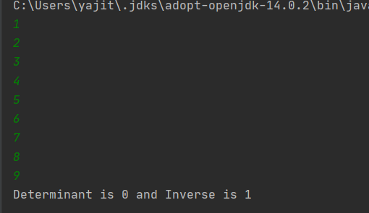

**Result:**

The determinant of 3x3 matrix is found and inverse of modular is also verified.

2.

Save the file content with regno and name

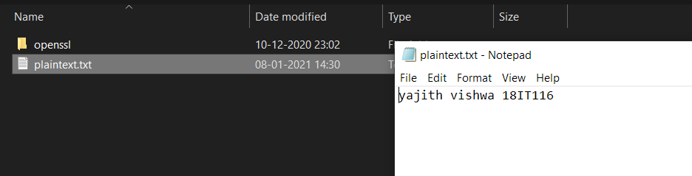

Display private key in hexadecimal value.

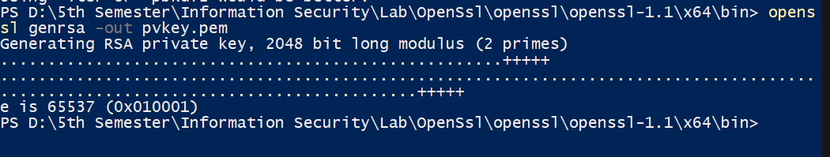

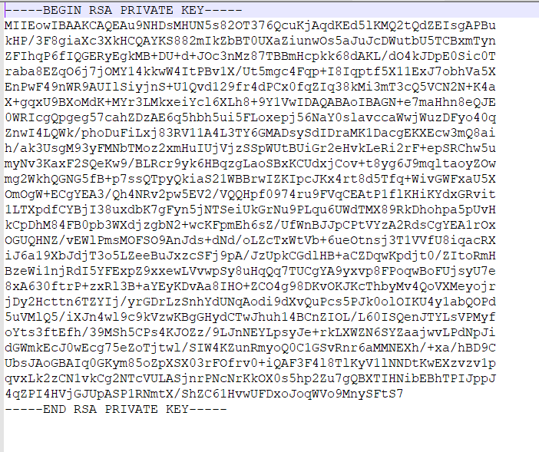

Perform encryption using RSA public key



Display the content of encrypted file.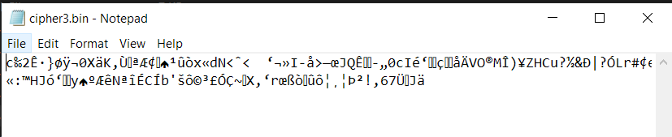

Decrypt the result using RSA private key.



Display the content of decrypt file.

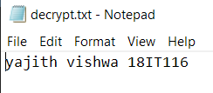

**Result:**

The file is encrypted and decrypted using openssl and verified